Chapter 3 terms - Crete & Greece

1. When was the Archaic Period -Debbi Wright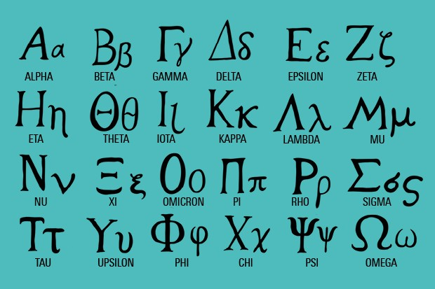

According to our textbook the Archaic Period was 650-480 BC. There were changes that were happening with the language, art, architecture, society and politics. There was an increasing amount of trade and population. During this time the earliest Democracy was born. Because of the increased population, there developed City-States. Another interesting fact is that the Greek alphabet was created during this time.

Toratora, Phyllis G, and Keith Eubank. *Survey of Historic Costume, 5th Edition*. Berg, 2009.

<https://www.worldhistory.org/Archaic_Period/>

<https://courses.lumenlearning.com/atd-herkimer-westerncivilization/chapter/archaic-greece/>

<https://www.historyextra.com/period/ancient-greece/ancient-greek-alphabet-letters-symbols-how-pronounce-origin/>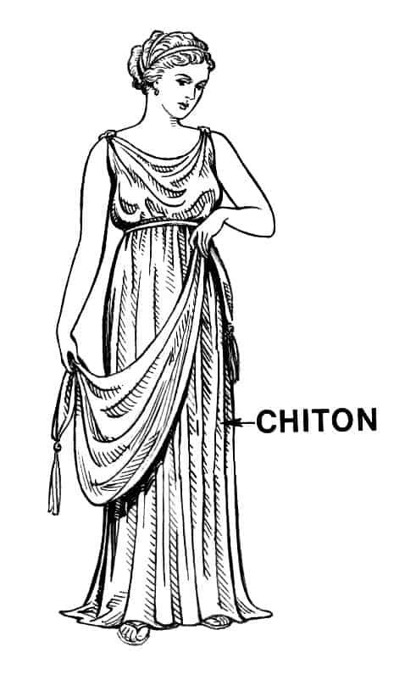

1. Chiton- Samantha Hooper

The chiton was the simplest and most commonly worn garment that was worn in ancient Greece. It was made of linen during the Ionic period and wool during the Doric period. They were draped over the body and pinned at the shoulder. They were typically sleeveless, and large belts called zosters were sometimes worn over the chiton around the waist. They typically were floor length.

<https://www.britannica.com/topic/chiton-clothing>

https://www.metmuseum.org/toah/hd/god3/hd_god3.htm

1. Chitoniskos - Jensen Hepworth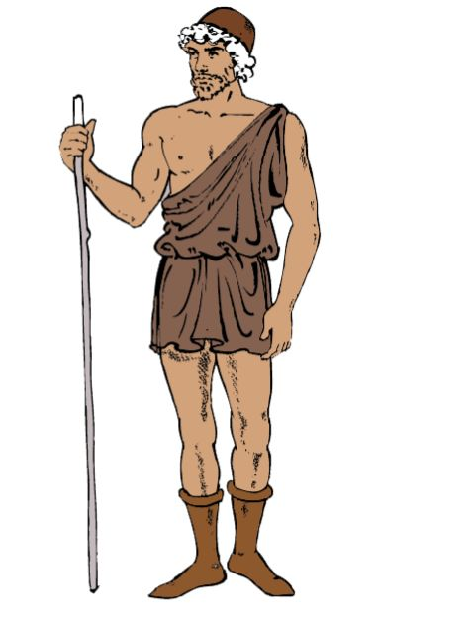

Chitoniskos were the shorty shorts for men in the Archaic period. They would usually go from the hip to the thigh. They were a close fit to the body and similar in shape to the Doric peplos. They are the shorter version of the Chiton. The garment fastens at the shoulder and is worn by men. They are usually made of patterned wool.

<https://www.pinterest.com/stephaniem28am/ancient-greek-chitoniskos-men/#:~:text=Chitoniskos%20was%20a%20short%20smock,Ancient%20Egypt>

<https://en.wikipedia.org/wiki/Chiton_(garment)>

Tortora, P. G., & Marcketti, S. B. (2021). *Survey of historic costume*. Fairchild Books.

1. Chlamydon- Jessica Fraser

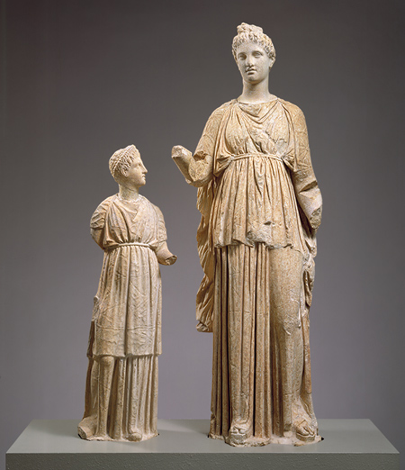

A fabric worn by the Greek Women. It was a more complicated style of robe that pleated into a fabric band. Women made all the clothing whether it was made from linen or wool. These were presented as modest, worn over clothing, and stretched from shoulder to ankle length.

Something I found interesting about the book and videos is how important modesty was to the women of Greece, especially compared to Egypt women.

I also learned that we know of clothing in Greece due to paintings on vases and sculptures and the study thereof.

Their art and building structures were spread across the world and we see them in important buildings and museums today.

Sources:

Survey of Historic Costume book pg. 65

<https://greeceandrome.wordpress.com/2014/02/13/greek-women/>

[(Links to an external site.)](https://greeceandrome.wordpress.com/2014/02/13/greek-women/)

<https://fashionhistory.fitnyc.edu/chlamys/>

1. Chlamys-Abigail Storrer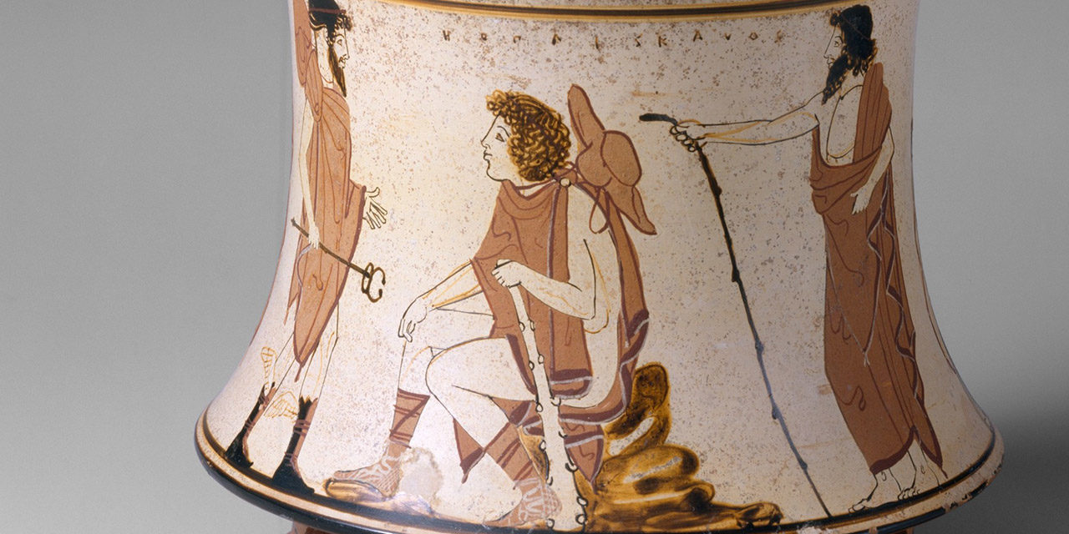

The chlamys was a short cloak worn by men in Greece. It was a long rectangular piece of fabric that they pinned at the shoulder and wore over top a chiton. This garment was popular for young men to wear but it was useful too. While simple it was easy to wear for those who needed freedom of movement. Not only traveling and using it as a blanket, but was also used by horsemen, hunters, and soldiers. The cloak was made out of either leather or wool. In Greece this was also one of the few clothing items that was strictly used by men only.

Tortora, P. G., & Eubank, K. (2010). *Survey of historic costume: A history of western dress*. Fairchild.

<https://fashionhistory.fitnyc.edu/chlamys/>

<https://www.encyclopedia.com/fashion/encyclopedias-almanacs-transcripts-and-maps/chlamys>

1. Cuirass- Savannah Jeppson

Cuirass is a modern term for “a closefitting, shaped armor that covered the body” (p69). Sometimes made of leather or metal, this would serve as protection during war. Weighing around 25 pounds, they were made in two separate pieces and then hammered together (Wikipedia). The cuirass was designed to mimic an idealized human physique.

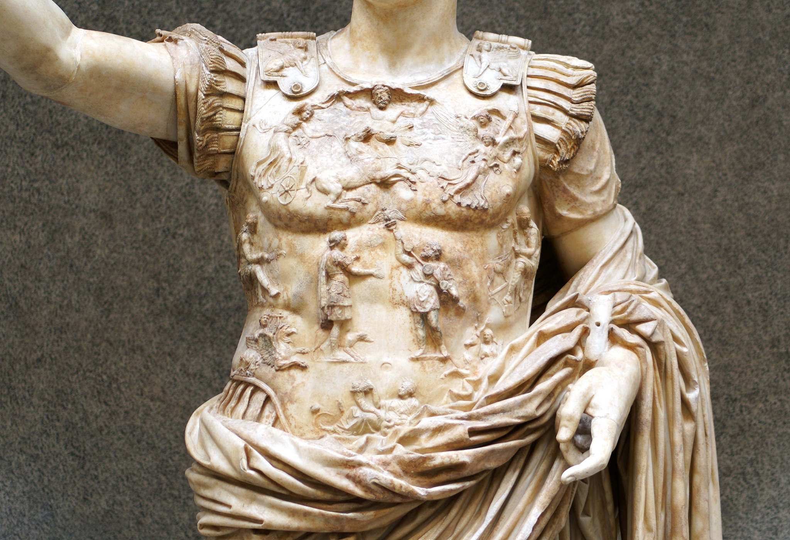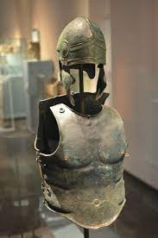

Sources:

<http://deepeeka.in/armouries/leather-armoury/ah6071l.html>

<https://en.wikipedia.org/wiki/Muscle_cuirass>

Survey of Historical Costume Book

1. Diplax - Claire Lynes

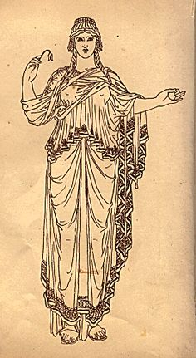

The Diplax was a small rectangle of fabric that was worn by women (Survey of Historic Costumes). The word diplax in greek means “double” because it was bigger than the chlaina (Fashion Encyclopedia). It was worn on top of the chiton and wrapped around the shoulders for modesty and warmth (Encyclopeda).

Sources:

<http://www.fashionencyclopedia.com/fashion_costume_culture/The-Ancient-World-Greece/Chlaina-and-Diplax.html>

<https://www.encyclopedia.com/fashion/encyclopedias-almanacs-transcripts-and-maps/chlaina-and-diplax>

Survey of Historic Costumes, Page 65

1. 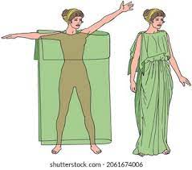Doric Chiton- Aubrey Reidhead

The Doric Chiton was typically a rectangle of wool or linen fabric that would often be worn with a belt to hold it in place. (History of Clothing) The sizing of it was that the rectangle be two times the width of the wearer, and it would be folded around the person in a tube-like fashion. (Encyclopedia of Fashion) This garment and its many pins in the sleeves was abandoned in favor of the Ionic Chiton because of a supposed stabbing with the use of the pins in chiton. (textbook)

[History of Clothing](http://www.historyofclothing.com/clothing-history/chiton/) [Encyclopedia of Fashion](http://www.fashionencyclopedia.com/fashion_costume_culture/The-Ancient-World-Greece/Doric-Chiton.html)

1. Doric Peplos - Abby Fluckiger

This was a women’s garment during the Archaic period. It was made of patterned wool, reached to the ankles, and fit close to the body, fastened with a long straight pin at the shoulder.

1. Empire Waistline = Marisa Bone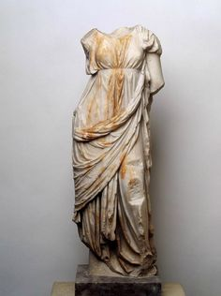

The Empire Waistline is in which a waistline of where a dress drapes out is fitted at the bust, and not at the waist. The Empire Waistline began in the Neoclassical-era when women began to copy the flowy Greco-Roman art, which featured thin ribbons cinched beneath the bust. A few trend-setting socialites even sprinkled themselves with water to enhance the clinging effect of the garments. Dresses fine enough to be drawn through a woman's ring were worn summer and winter, contributing to epidemics of influenza, which was called "muslin disease" during the Neo-classical era. A contemporary rhyme lamented:

"Plump and rose was my face

And graceful was my form,

Till fashion deemed it a disgrace

To keep my body warm."

[Source 1](https://www.masterclass.com/articles/empire-waist-dress-guide#what-is-the-difference-between-aline-and-empire-waist-dresses) [Source 2](https://www.folkwear.com/blogs/news/history-of-the-empire-dress) Book

1. Exomis - Jocelyn Munoz

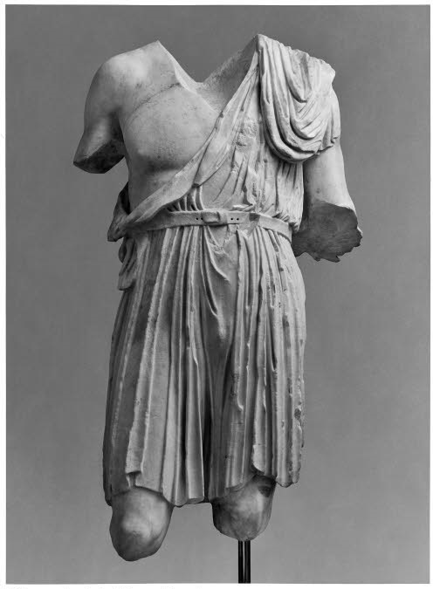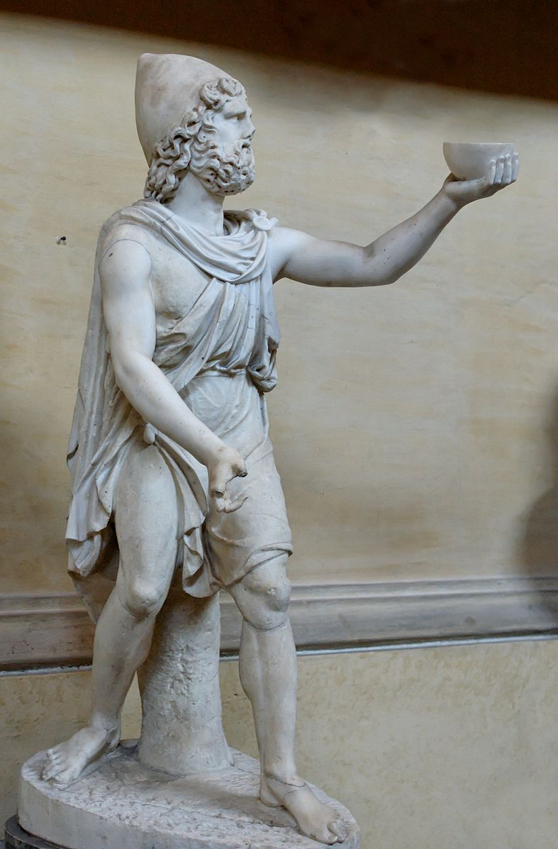

The word Exomis came from the Greek words exo and omos, which means “outside” and “shoulder” respectively. This garment came to be used more in the fifth century when it replaced the older chiton. They became more and more popular since they were shorter and allowed for more movement and increased coolness. Since they were only draped over one shoulder their left arm was left exposed which aided in using weapons

Tortora, P. G., & Marcketti, S. B. (2021). two. In *Survey of historic costume* (pp. 62, 71). essay, Fairchild Books.

<https://fashionhistory.fitnyc.edu/exomis/>

<https://www.stronghold-nation.com/history/ref/exomis>

1. Fibulae-Anna Ament
2. Greaves - Irelynd Preece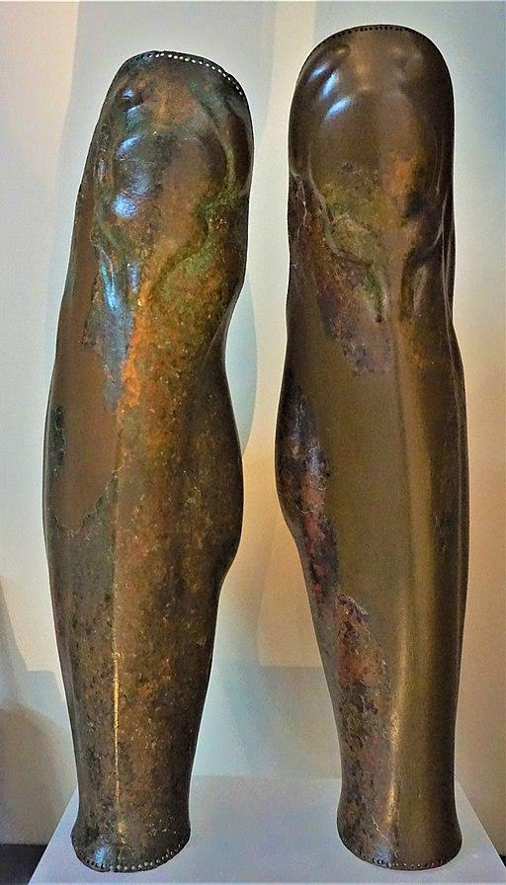

The word greave literally means "armor for the shin." In the Greek culture, it was used as part of their military costume. The greaves were made of leather or metal that was shaped to protect the lower legs. It was said that the primary purpose of the greaves was to protect the tibia, which is located in the lower leg. The tibia is a bone that is very near the surface of the leg and was said to be extremely vulnerable in any attack. So they used greaves to protect themselves.

Sources:

book

<https://www.merriam-webster.com/dictionary/greave>

<https://joyofmuseums.com/museums/europe/greece-museums/thessaloniki-museums/archaeological-museum-of-thessaloniki/ancient-greek-greaves/#:~:text=These%20pair%20of%20Ancient%20Greek,to%20just%20about%20any%20attack>.

1. Greek Parthenon - Esther Wambold
2. Greek Theatrical Tragic Masks- **Ryann Becker**

**Greek theatrical tragic masks were used in the theater. They defined the characters that were being betrayed. Though, an audience member could also identify a character by a specific style of dress, color, or special insignia. (textbook) This allowed actors to play multiple characters. In the tragic plays, the masks were more life-like. These masks were made of nondurable substances, so there are no original masks today. We know of them because they are depicted in many works of art.**

**Resources:**

**<https://artsedge.kennedy-center.org/interactives/greece/theater/playersProps.html#:~:text=In%20a%20tragedy%2C%20masks%20were,durability%2C%20and%20none%20has%20survived>**

**[(Links to an external site.)](https://artsedge.kennedy-center.org/interactives/greece/theater/playersProps.html#:~:text=In%20a%20tragedy%2C%20masks%20were,durability%2C%20and%20none%20has%20survived)**

**<http://www.teachinghistory100.org/objects/about_the_object/greek_theatre_mask>**

**[(Links to an external site.)](http://www.teachinghistory100.org/objects/about_the_object/greek_theatre_mask)**

1. Hauberk- Elizabeth Nathan

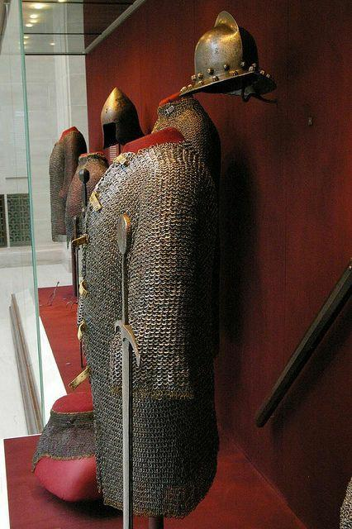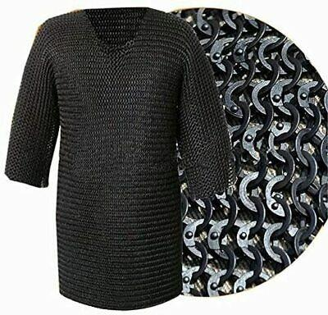

The hauberk is typically a type of mail armor which is constructed of interlocking loops of metal woven into a tunic or shirt. The sleeves sometimes only went to the elbow, but often were full arm length, with some covering the hands with a supple glove leather face on the palm of the hand, or even full mail gloves.

It roughly weighs 22lb (10kg) and the weight of the garment is unevenly distributed, the stress falls mainly on the shoulders.

<https://military-history.fandom.com/wiki/Hauberk>

<https://www.dictionary.com/browse/hauberk>

1. When was the Hellenic Period - Classical Greece. -Jalissa Cloward

The Classical Age began in 500 BC when Democracy was established. It was a “golden age” for Greece. There were many famous artists and philosophers during this time. The end of the Classical Age and the beginning of the Hellenic Period is marked by the death of Alexander the Great in 323 BC. Due to the additional territory Alexander the Great had conquered, new ideas and developments were able to flourish. The culture went through many changes. The Hellenic period ended in 31 BC with the rise of Augustus of Rome.

*Survey of Historic Costume* pg. 57-58

<https://www.worldhistory.org/Hellenic_World/>

<https://www.colorado.edu/classics/2018/06/14/hellenistic-period-cultural-historical-overview>

1. Hellenic Chiton -Ida Johnson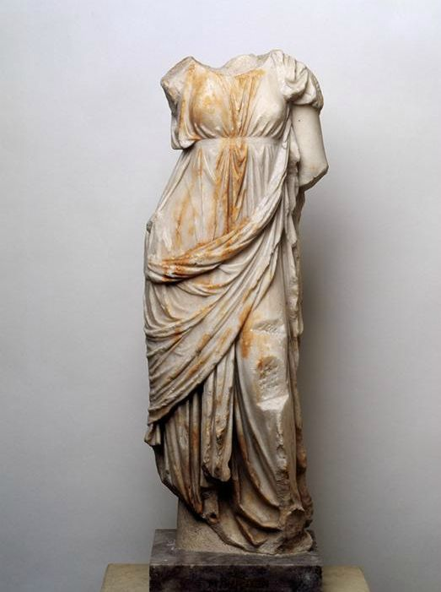

The chiton was fashioned from a single sheet of material folded across the body. The garment could be sewn along the top of the arms, leaving only a small hole for the head or neck. Alternatively, the chiton could be left sleeveless. The chiton was made of a lighter material, such as linen or silk.The Hellenic Chiton is often pulled up under the breast for women, creating a different waistline than men.

<https://www.colorado.edu/classics/2018/06/18/womens-dress-archaic-greece-peplos-chiton-and-himation>

<https://www.britannica.com/topic/chiton-clothing>

1. Hercules Knot - Alex Clark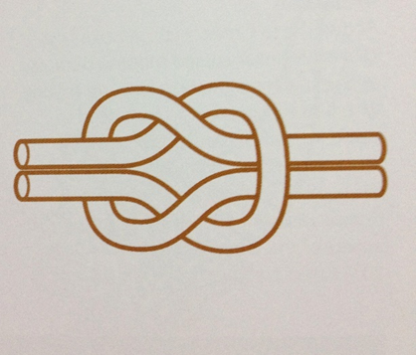

The Hercules Knot is a knot that was used on the belt for a bride’s wedding dress. The Hercules Knot can also be known as the Bridal Knot as well. The knot is essentially a square knot but is connected with symbolism. The knot itself was a symbol of love and marriage and the loosening of the knot was a symbol of the union between the bride and groom on their wedding night. The loosening of the knot was held exclusively for the groom of the bride. The knot is actually used within medicinal practices in the past and even in the present. This was due to the original belief that the Hercules Knot would help to heal wounds faster when they were bound by this knot.

Survey of Historic Costumes, Page 68

<https://www.pinterest.com/pin/405957353884486226/>

<https://en.wikipedia.org/wiki/Reef_knot>

<https://symbolsarchive.com/hercules-knot-history-meaning/>

1. Himation - Hannah Ferreira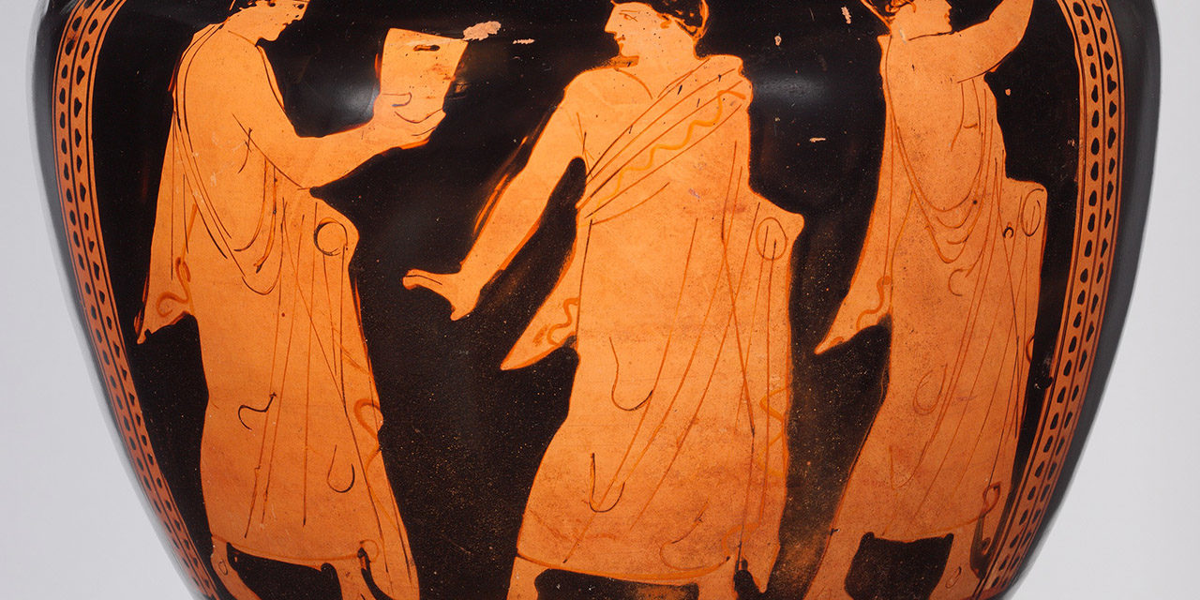

Pronounced Hee-Ma-Tee-On, the Himation was a huge rectangular piece of fabric that wrapped around the body. It was usually draped over the left shoulder. Both men, women and youth wore this garment over a chiton, and it was commonly worn by the Gods in the images depicted of them. The himation could have been used as a veil for women when in the presence of strangers.

<https://fashionhistory.fitnyc.edu/himation/>

Tortora, Phyllis G, and Keith Eubank. *Survey of Historic Costume*. 5th ed., Fairchild, 2010.

<http://www.fashionencyclopedia.com/fashion_costume_culture/The-Ancient-World-Greece/Himation.html>

1. Ionic- Hailey Child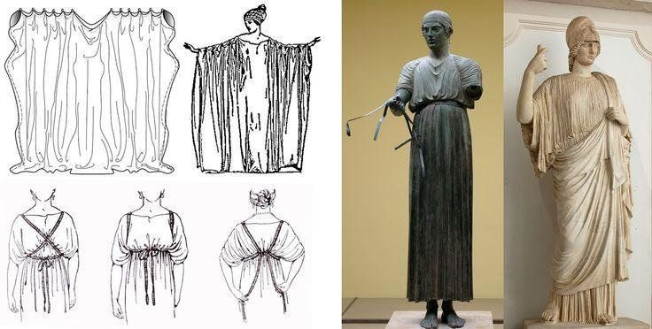

The ionic chiton was the most popular greek garment in the fifth century BCE. It was more of a gown than a tunic. It was a very intricately draped garment with pleats and folds. It was made from a light linen fabric usually dyed with bright colors and embroidered with stars, birds and other designs. It was worn by both men and women and on occasion made with silk. Something I found interesting was that men would mostly wear white or beige colors while woman would wear brighter colors like blue, purple, and green. Both genders would use a belt or sash to tie the fabric and cinch it at the waist and have the fabric bag over the belt.

<https://fashion-era.com/ancient_costume/ancient-greek-dress-chiton.htm>

Survery of Historic Costume

<http://www.fashionencyclopedia.com/fashion_costume_culture/The-Ancient-World-Greece/Ionic-Chiton.html>

1. Laurel Wreath - Savannah Tanner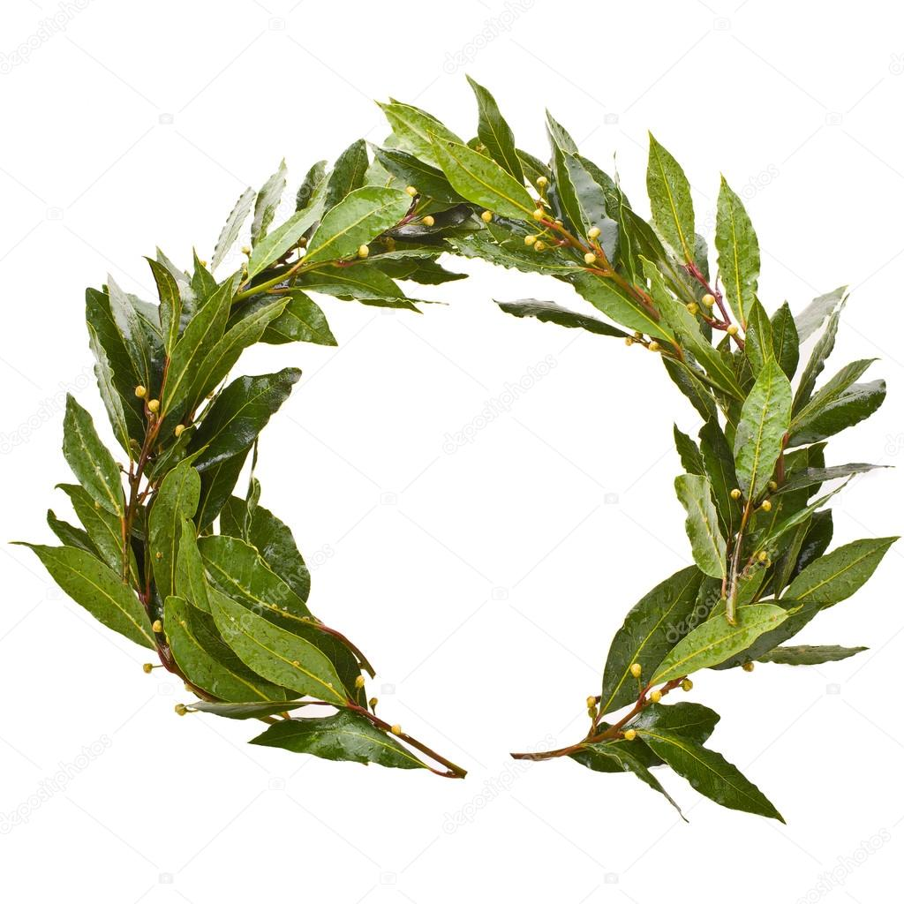

A laurel wreath was something given to brides and grooms as a religious symbol meant to signify glorifying mortals with divine meaning. The laurel wreath was a symbol of Apollo. Laurel wreaths were also awarded to those with exceptional prowess, either as an athlete of the olympics or the literary arts. It can be adorned on the head or around the neck. Laurel leaves were believed to have cleansing properties for the mind and the body. It was also something that signified the wealthy during ancient Greece. The laurel wreath today symbolizes peace.

<https://www.ancient-symbols.com/symbols-directory/laurel-wreath.html>

<https://mythologian.net/laurel-wreath-crown-symbol-meaning-history/>

Survey of Historic Costume, Page 68

1. Greek Olympic Games - Amanda Hair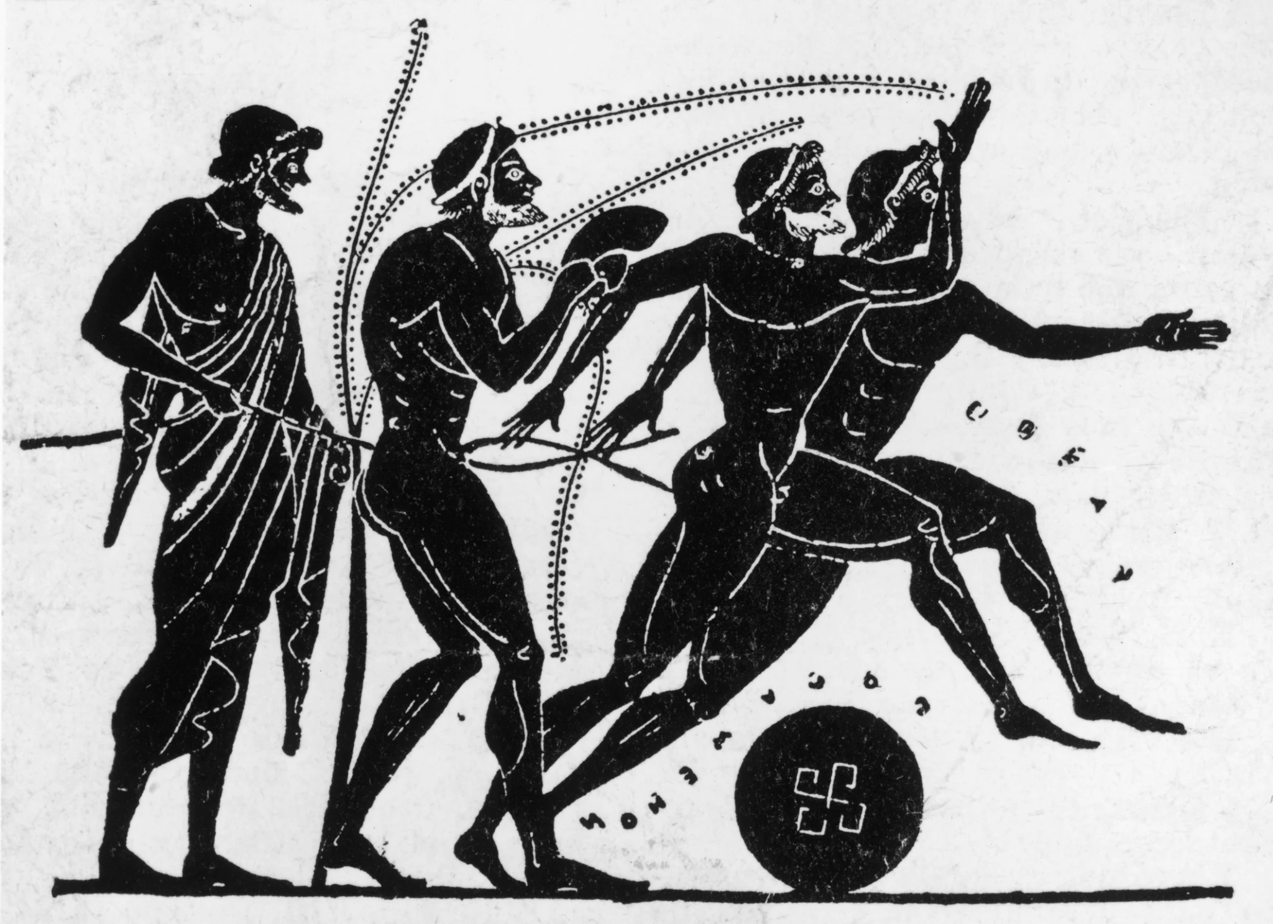

The ancient Greek Olympic games started as a one-day event but eventually became a 5 day affair. Athletes competed in running, long jump, shot put, javelin, boxing, pankration and equestrian events. It is said that, “At their heart, the Games were a religious festival and a good excuse for Greeks from all over the Mediterranean basin to gather for a riotous barbeque. On the middle day of the festival a vast number of cows were slaughtered in honor of Zeus, King of the Greek Gods – once he had been given a small taste, the rest was for the people.” It’s interesting to note that many of the contestants competed naked. Fashion was apparently not their top interest. The Penn Museum site explained, “There are two stories relating to the question of nudity at the ancient Olympic Games. One story states that it was a runner from Megara, Orsippos or Orrhippos who, in 720 B.C. was the first to run naked in the [stadion](https://www.penn.museum/sites/olympics/olympicglossary.shtml) race when he lost his shorts in the race. Another tradition is that it was the Spartans who introduced nudity to the Olympic Games in the 8th century B.C. as it was a Spartan tradition. It is not clear if the very first recorded victor at Olympia, Koroibos, who won the [stadion](https://www.penn.museum/sites/olympics/olympicglossary.shtml) race in 776 B.C. wore shorts or not. It seems fairly clear that by the late 8th century nudity was common for the male contestants.” Nudity was not generally accepted, but for the athletes performing in the nude they had a religious context: Perfection of the soul, perfection of the body.

**Sources**

<https://olympics.com/ioc/ancient-olympic-games/the-sports-events#:~:text=The%20ancient%20Olympic%20Games%20were,boxing%2C%20pankration%20and%20equestrian%20events>.

<https://www.penn.museum/sites/olympics/olympicorigins.shtml>

Survey of Historic Costumes, Page 61-62

1. Who are the Minoans?-Marisol Dejesus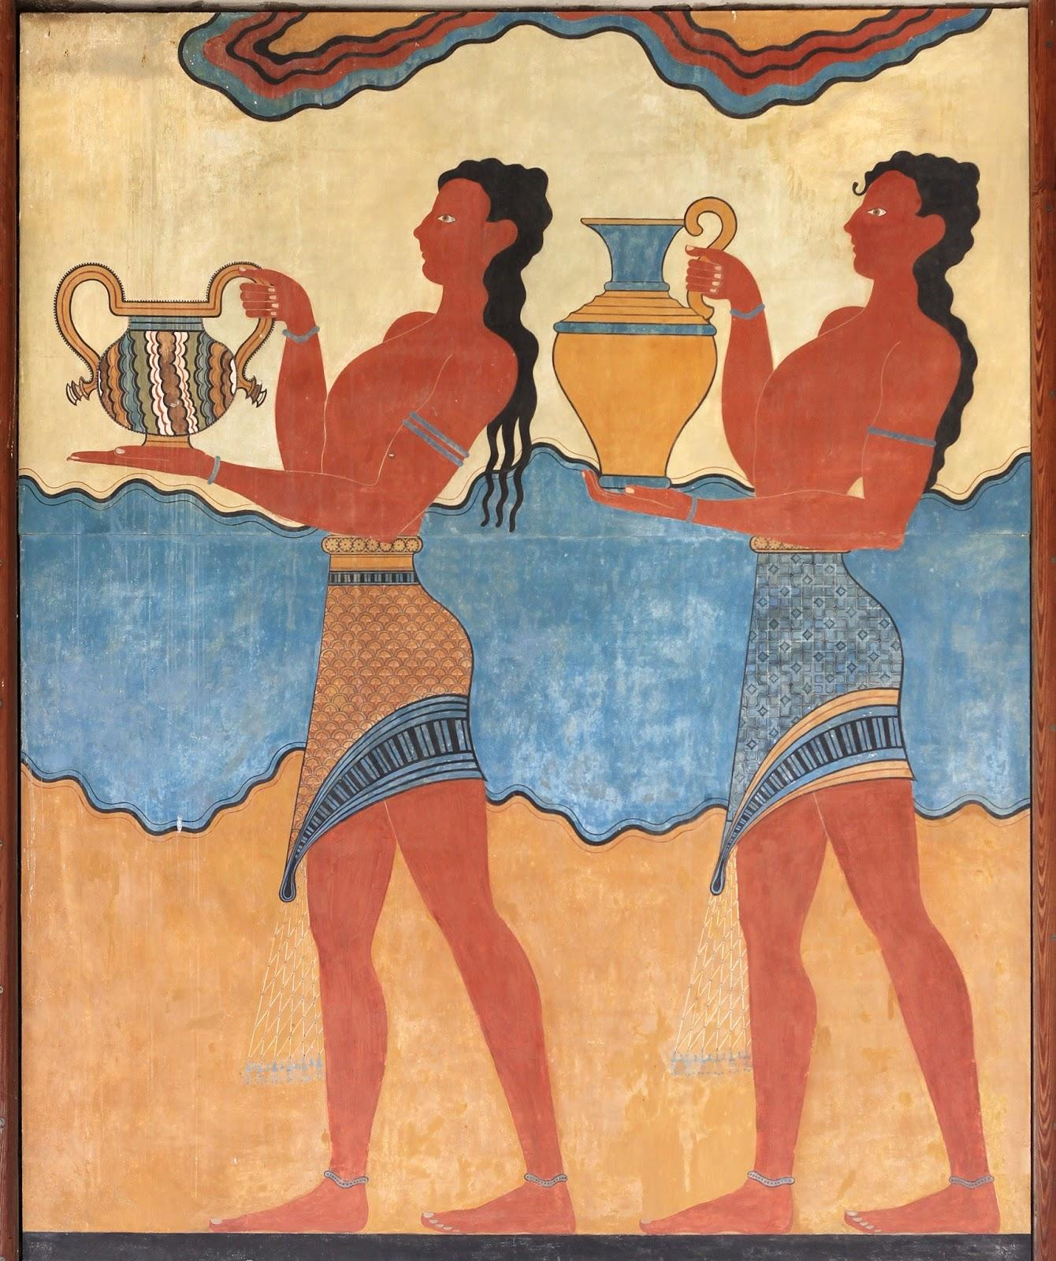

Minoan are people who lived on the island of Crete, which is part of Greece in the Mediterranean Sea. They came from the Bronze age. The Minoan receive their name from a British archeologist called Sir Arthur Evans. Sir Arthur Evans named the Minoan after the legendary King Minos. The Minoan were seafaring people who carried trade with Egypt, Spain, Syria, and Sicily. They enjoy peace, prosperity and develop an elegant culture.

Sources:

Book pg.52

<https://www.timemaps.com/civilizations/minoan-civilization/>

<https://study.com/academy/lesson/minoan-civilization-facts-map-timeline.html>

1. Describe Minoan Costume Abbie Burns

The Minoan discovered spinning, weaving and dyeing the textiles linen and wool. The men wore loincloths and kilts while the women wore robes with short sleeves with layered flounced sleeves. Each skirt had small wasp waists typically taken to extremes. 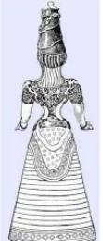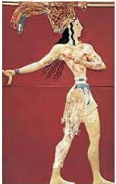

Sources:

Text book pg:53

<https://www.slideshare.net/apetitedelight/minoan-civilization-13204885>

<https://en.wikipedia.org/wiki/Minoan_civilization#:~:text=As%20seen%20in%20Minoan%20art,often%20taken%20to%20improbable%20extremes>.

1. What is Mycenaean? Andrea Lazaro Hernandez

The Mycenaean civilization was a strong city-state that overtook the Minoan civilization, and extended through Peloponnese, Crete and the Cycladic islands. According to Greek mythology, Perseus, a son of Zeus, gave the place the name of Mycenaea as a sign of good omen by finding water after picking some myces (fungus). It is also believed that Perseus commanded cyclops (one-eyed giants) to build the big walls that surrounded the city; the remains of these walls still stand nowadays. Mycenaean art portrayed nature, religion, and war, and consisted mostly of pottery, frescoes, and goldwork. The art of Mycenaea served as inspiration for later Greek art.

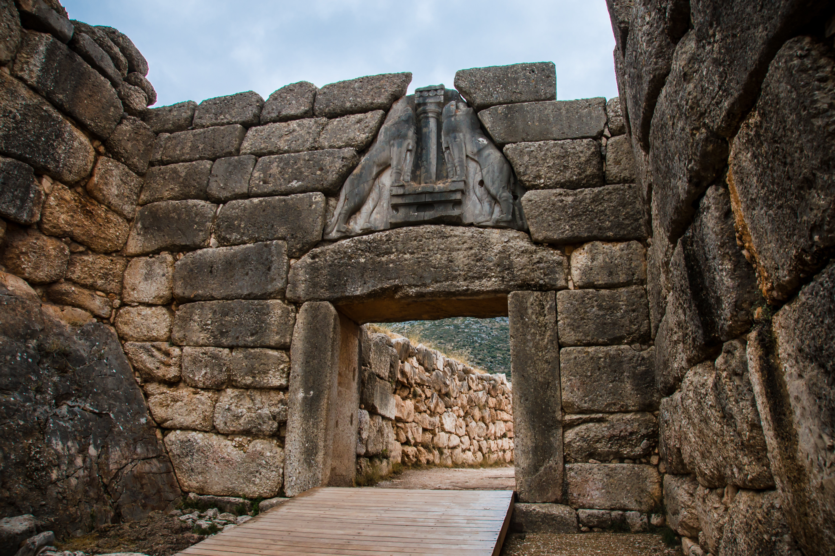

Sources:

<https://www.history.com/topics/ancient-greece/mycenae>

<https://www.worldhistory.org/Mycenaean_Art/>

Survey of Historic Costumes, pages 51 and 52

1. Nymphides- jamie rakes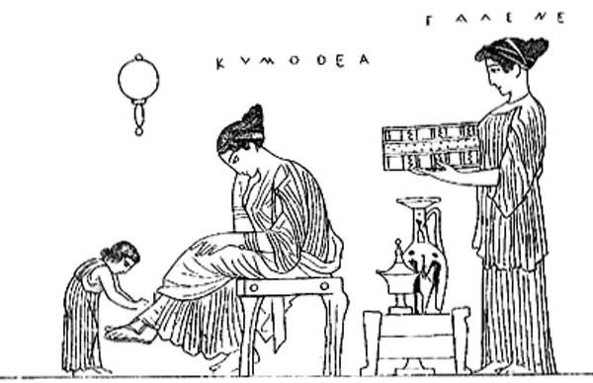

Nymphides are a bridal shoe worn in an Ancient Greek wedding ceremony by the bride. The ancient Greeks paid very close attention to the shoes and made it important in their ceremonies.

Textbook page 49

<http://www.ime.gr/chronos/05/en/society/wed_stages.html>

<https://www.jstor.org/stable/20169130?seq=4#metadata_info_tab_contents>

1. Perizoma- Claire Moore 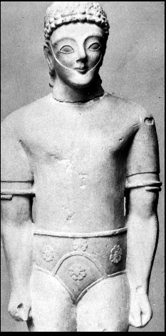

The Perizoma is the greek version of the loincloth. This was a fitted garment that was worn closest to the skin. The book describes them as covering the same area as modern athletic briefs. Perizoma were worn by both men and women, and typically acted as their underwear. Although most of the time they were worn under something some laborers worn them alone as outer garments.

<https://www.worldhistory.org/article/20/ancient-greek-clothing/>

<https://en.wikipedia.org/wiki/Perizoma_(loincloth)>

Book pages 54 & 77

1. Petasos: Lexie Pincock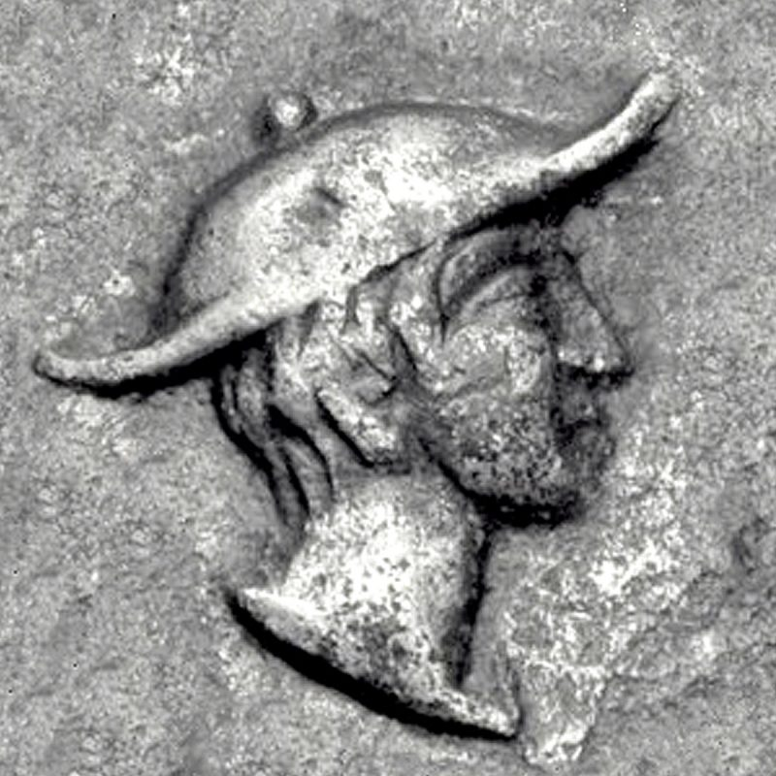

A type of hat. Often worn with the chlamys cape. Common material was wool felt, leather or straw. It had a wide brim with a strap under the chin so it could hang around the neck when not in use. It became a symbol for Hermes.

Sources:

Pg. 65

<https://hatguide.co.uk/petasos/>

<https://www.britannica.com/topic/petasos>

1. Phrygian Bonnet - Kimberly Tesam Moita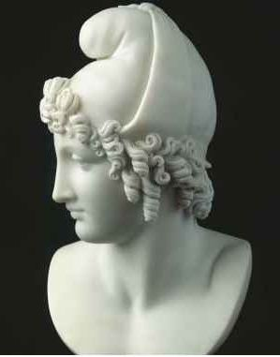

The Phrygian bonnet is a soft cap with a bent top usually used to depict foreigners in Greek art. It originated in Anatolia in the ancient country of Phrygia. There are mythological figures in ancient art that are depicted with the caps like the Trojans, Perseus, and Ganymede. There was also a Roman cult called the cult of Mithras, and all info is available from monuments and temples, that depicted Mithras killing the bull in an underground cave, with a Phrygian bonnet. His followers wore the cap, and we know from preserved art that it was red due to the underground nature of the temples preserving frescos and reliefs of Mithra and his bonnet. Later on, the cap was used for a symbol of freedom, and with the murder of Julius Caesar, the people donned the Phrygian bonnet in a form of freedom from their oppressive emperor. It was a symbol of resistance and freedom called “the red cap of liberty” later on during the French Revolution.

<https://www.britannica.com/art/Phrygian-cap>

<https://hyperallergic.com/436182/before-maga-mithras-phrygian-caps-and-the-politics-of-headwear/>

<https://www.tertullian.org/rpearse/mithras/display.php?page=main>

1. Pilos-Brittany Pocock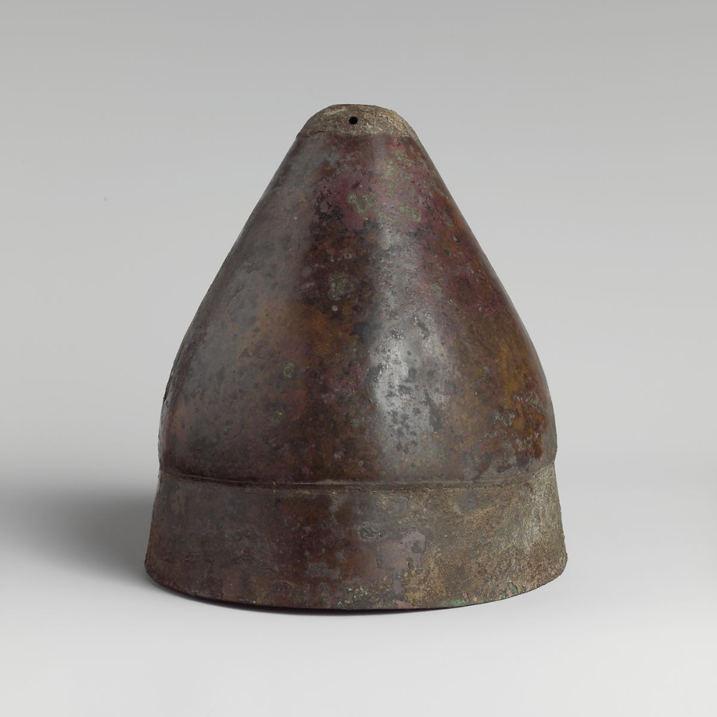

A narrow brim hat or brimless hat with a pointed crown. This hat is often depicted in art. At the end of the 5th century the pilos helmet occurred in sparta. During the following centuries the helmet became a popular infantry helmet. Theories suggest that some had a chin strap. It is suggested that spartans adopted this helmet as a sign of bravery. They usually were made out of bronze. A sort of replica is worn today in Albania and Kosovo. These helmets represent the need to hear and see on the battlefield at the time because they are not as restrictive as some of the other helmets used at later times.

[Ancient Greek Helmets: 8 Types and their Characteristics (thecollector.com)](https://www.thecollector.com/ancient-greek-helmets-8-types-and-their-characteristics/)

[Alexander Ancient Art - A Greek Bronze Pilos Helmet](https://www.alexanderancientart.com/1086.php#:~:text=The%20Greek%20word%20pilos%20originally%20indicated%20wool%20or,%28of%20another%20type%29%20which%20is%20lined%20with%20felt.)

Survey of Historic Costume.

1. Stephane- Bailey Pinder

The stephane was a special crown worn by a bride on her wedding day. It was worn over a veil. Some painting suggest they were made out of metal, while others indicate they were made out of flowers and other greenery, including asparagus which was thought to have significance. Plutarch wrote that asparagus symbolizes the importance of companionship between husband and wife despite the hardships at the beginning of the marriage. A version of the stephane can still we worn in modern Greek Orthodox weddings today.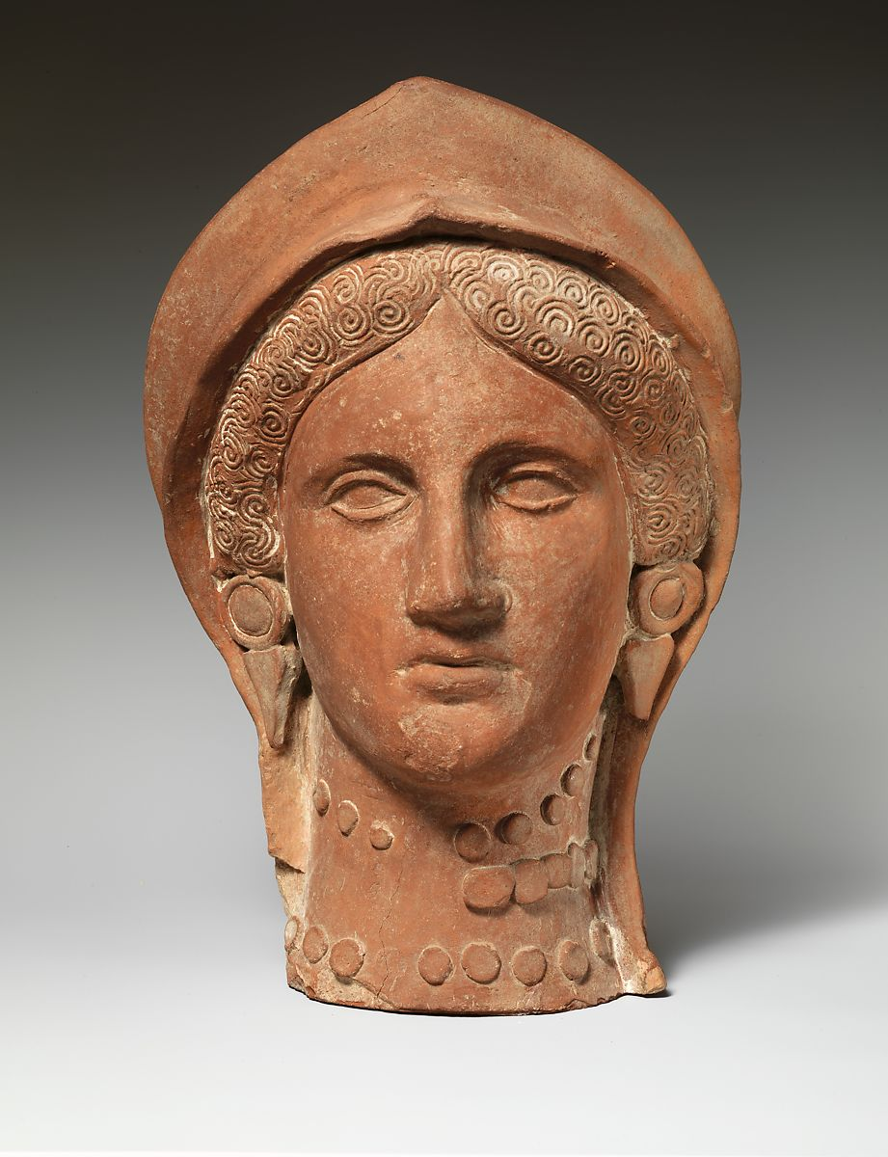

<https://womeninantiquity.wordpress.com/2018/11/27/bridal-attire-in-ancient-greece-and-rome/>

*The Nuptial Ceremony of Ancient Greece and the Articulation of Male Control Through Ritual,* Casey Mason <https://digitalcommons.macalester.edu/cgi/viewcontent.cgi?article=1005&context=classics_honors>

*Survey of Historic Costume,* pg 68

1. Swaddling Clothes: Madison Frost

Swaddling is the practice of wrapping an infant child in some type of fabric which limits his ability to move. “Swaddling bands” were also used to help and further restrict the child. Swaddling fell out of tradition in the 17th century. In the 17th century swaddling started to represent neglect. England later would abolish this practice. Historians believe that swaddling arose in the paleolithic period. The earliest representations came from Crete and Cyprus. They are also found in Ancient Greek and Roman tombs. 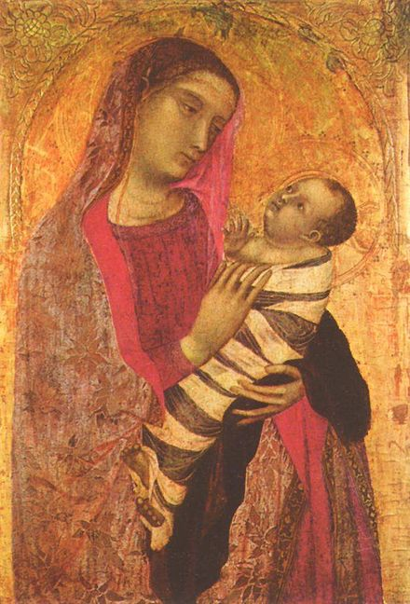

Tortora, Phyllis G, and Keith Eubank. *Survey of Historic Costume*. 5th ed., Fairchild, 2010.

<https://en.wikipedia.org/wiki/Swaddling>

<https://www.biola.edu/blogs/good-book-blog/2021/what-are-swaddling-clothes>

1. What is the misunderstanding of the Greek use of “Color”?- Lauren Shumway 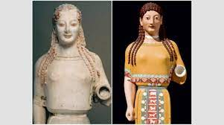

The misunderstanding of the Ancient Greeks' use of colors in clothing comes from the marble statues having been bleached of all paint used on the statues after being exposed to the elements for centuries. This was later continued to be enforced by early archeology praising the statues with the less paint as the image of beauty some people scrubbed off the trace of paint. More recently researchers have analyzed pigment on the statues and found clothing being painted green, blue, yellow, ochre, red and in many different patterns.

Tortora, Phyllis G, and Keith Eubank. *Survey of Historic Costume*. 5th ed., Fairchild, 2010.

<https://www.smithsonianmag.com/arts-culture/true-colors-17888/>

<https://www.metmuseum.org/toah/hd/grdr/hd_grdr.htm>

1. Anakalypteria: Kya Boyd 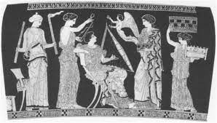

Marriage in Greek costumes was not based on personal relationships or the idea of marrying someone you love as it is today. Marriage was more of a public interest arranged by the parents to keep a political view or based on the laws that need to be fulfilled.Although the marriage ceremony is important, the marriage is not legal until they are living together. In some situations women were married to their uncles or cousins for the family's own gain. Since the marriage is arranged by the fathers of the family the couples do not see each other until the wedding day. During the wedding they begin a ritual that is important for the women to follow which is the anakalypteria.This ritual is very important because in Greek culture women are oftenly veiled in their everyday life as a way of reserving their modesty. Anakalypteria is the ritual of unveiling the bride during a marriage ceremony as a symbol of the bride's willing acceptance of the groom.

Sources

<https://en.wikipedia.org/wiki/Marriage_in_ancient_Greece>

<https://bmcr.brynmawr.edu/2004/2004.06.09/>

Tortora, Phyllis G, and Keith Eubank. *Survey of Historic Costume*. 5th ed., Fairchild, 2010. Pg 68